# 

Game Design Documentation

CSIE1601-U201612696-Chen Haorui

2017-10-17 _

# Introduction

"Kingdom Rush Frontiers " ( Kingdom Rush Frontiers ) is a small [tower defense game](https://baike.baidu.com/item/%E5%A1%94%E9%98%B2) produced by IRONHIDE [in Uruguay . It was released on](https://baike.baidu.com/item/%E4%B9%8C%E6%8B%89%E5%9C%AD) [the Flash](https://baike.baidu.com/item/Flash) game website Armor Games on June 6, 2013 . There are PC , iPad, iPhone and Android versions.

# Design document structure and content

GCD is a concise, clear, high-level document that summarizes the content of the game. Specific requirements are as follows.

* game concept
  + Game Appearance: 2D Overlook
  + Game Category: Tower Defense
  + Theme: War, Adventure, Magic
* Game brief

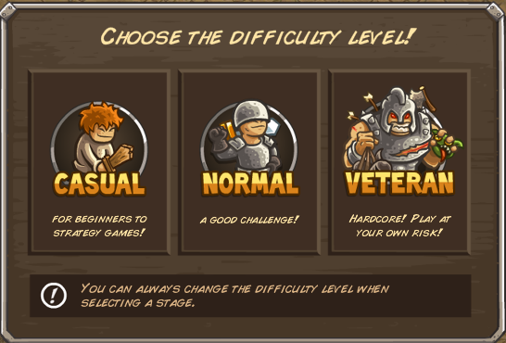

* + Difficulty selection : Easy, Normal, Hard. As the difficulty increases , the enemy's HP and abilities gradually increase.

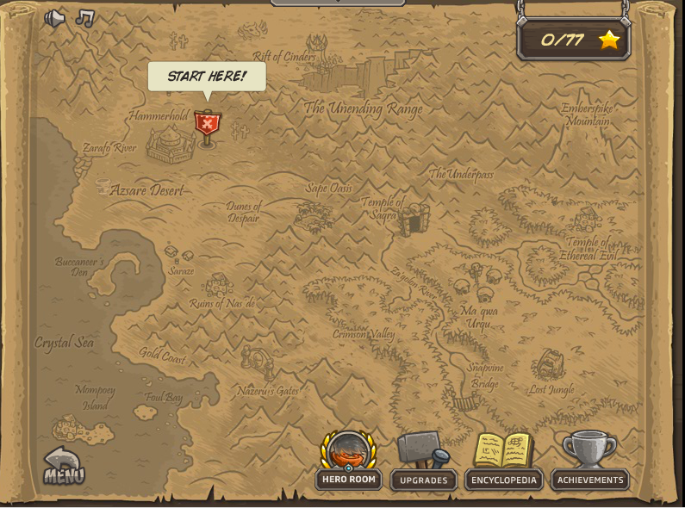

* + Map & Main Interface: Select a level.

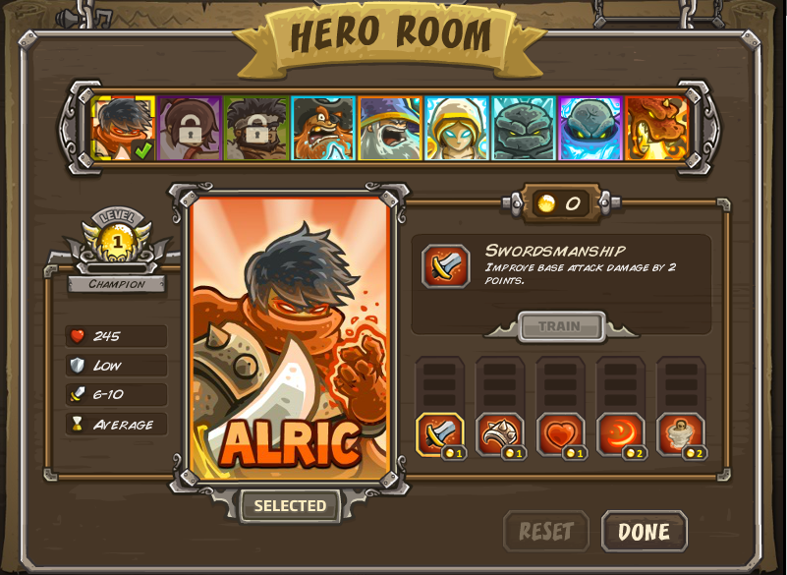

* + H ERO ROOM : Select the heroes supported in the level and upgrade their skills. Some heroes will be unlocked after breaking the specified level, and some heroes and skills need to be recharged for purchase.

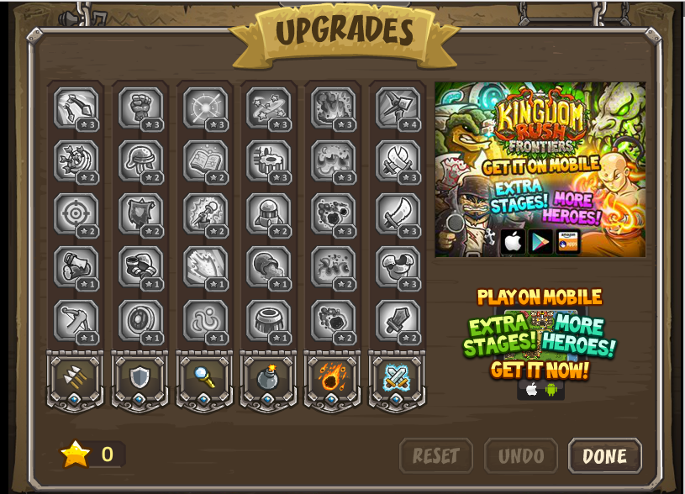

* + U PGRADES : Upgrades for attack towers , fixed-point bombing skills, and call for support skills . Stars can be obtained by breaking levels.

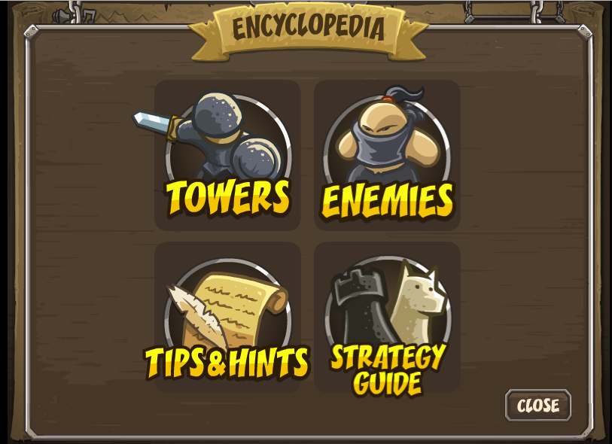

* + E CYCLOPEDIA : The TOWERS section provides a list of the parameter skills of the unlocked attack towers ; the ENEMIES section provides a list of the parameter skills of the enemies that have appeared; the TIPS&HINTS section has some detailed tips that are easy for players to ignore and are helpful to the game ; STRATEGY GUIDE is The external link leads to the official game clearance demo .
* Target population
  + Fans of the previous games in this series 🡪are tower defense game enthusiasts 🡪of all ages .
* figure

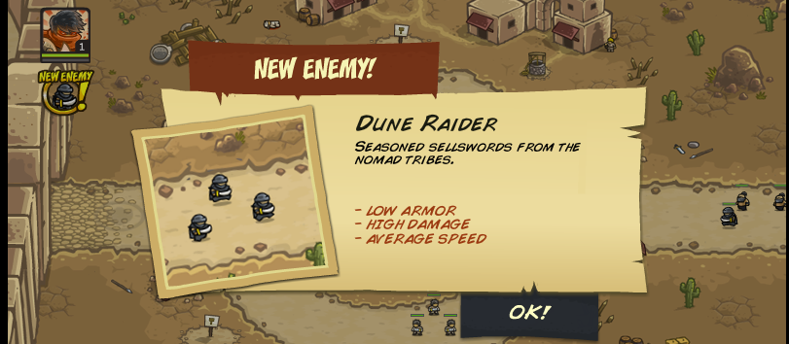

* + When a new type of enemy appears, there will be a prompt on the right . After clicking on it, the above interface will appear , including the enemy's name, appearance, introduction and ability parameters .



* + Enemy specific parameter panel, including type, blood volume, attack power, defense level ( including physical, magic) and threat degree ( consuming our life )

 

* + Our defense tower parameter panel . For barracks, it includes soldiers ' blood volume, attack power , defense level and resurrection time; for turrets , magic towers and arrow towers, it includes attack power, attack speed and attack range.
  + Ability, Energy, Blood Gain, Blood Loss: After each tower reaches 4 levels, you can choose the category and use gold coins to upgrade skills. Soldiers in the barracks have blood volume and need time to revive after death.
* player character
  + The commander-in-chief of the army is responsible for arranging troops and commanding heroes to move on the battlefield . Off the battlefield , he is responsible for upgrading the capabilities of ordinary soldiers and buildings , recruiting heroes, and upgrading skills, and overthrowing the base camp of invaders through battles
* game world
  + What types of things does the game world contain?

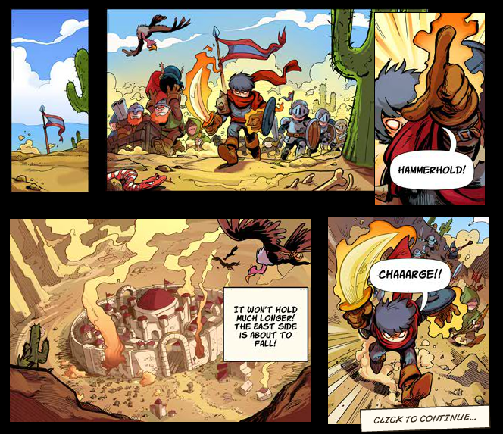

* + Visual and auditory experience: There are modern American short comics similar to the picture above in front of each level , which can enhance the fun of the game while explaining the background and plot . The background music of the map interface is in the style of western fantasy adventure, and the sound and visual effects of the battle interface are fine. There will be metal collision sounds when building defense towers and infantry battles. When the enemy dies , there will be wailing and words like 'OOF!
  + Exterior

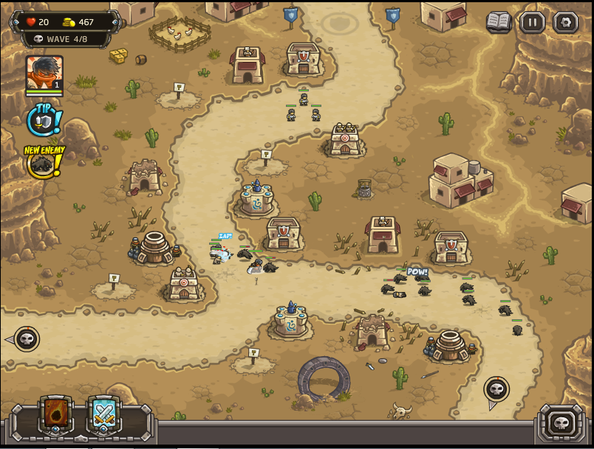

In the level interface, the upper left corner shows the remaining blood volume, money , and passed enemy waves; the page button in the upper right corner can call ENCYCLOPEDIA; pause ; the setting button menu has picture and sound effect quality settings . The blue icon in the lower left corner is the summoned militia (shorter cooling time, low damage ) ; the red icon is meteor shower (longer cooling time, high damage ). Move the mouse to the skeleton at the starting point of the road to get the next batch of enemy troops . Click to release the next group of enemies in advance , and the advanced time will be deducted from the cooling time of the two skills and converted into corresponding money.

* + Terrain, damage, or other events: the enemy advances along the fixed road on the map , and when the enemy breaks through the defense and enters the base , the remaining HP of the base will be deducted according to its threat .
* game mechanics

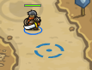 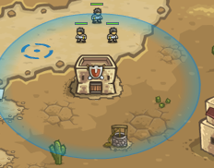

* + How characters move, combat mechanics, puzzles, or other resources: Heroes and infantry can choose a standby location by clicking on the hero villain/barracks . Easter eggs sometimes appear on the map (such as the black warrior in Star Wars ) , and some achievements in ACHIEVEMENTS can be unlocked after finding them .
  + Winning and losing conditions: Winning conditions - after destroying all enemies, there is still blood left in the base , and the level rating is determined according to the amount of blood. In the elite and extreme modes , the base has only one bar of blood, and you will win after destroying all enemies. The level fails when the blood volume of the base is 0 .
* quote
  + Baidu Encyclopedia: Royal Guard